78. Based on the story, state whether each statement in the table below is true or faise, then  
give one reason why you think so. [3m]

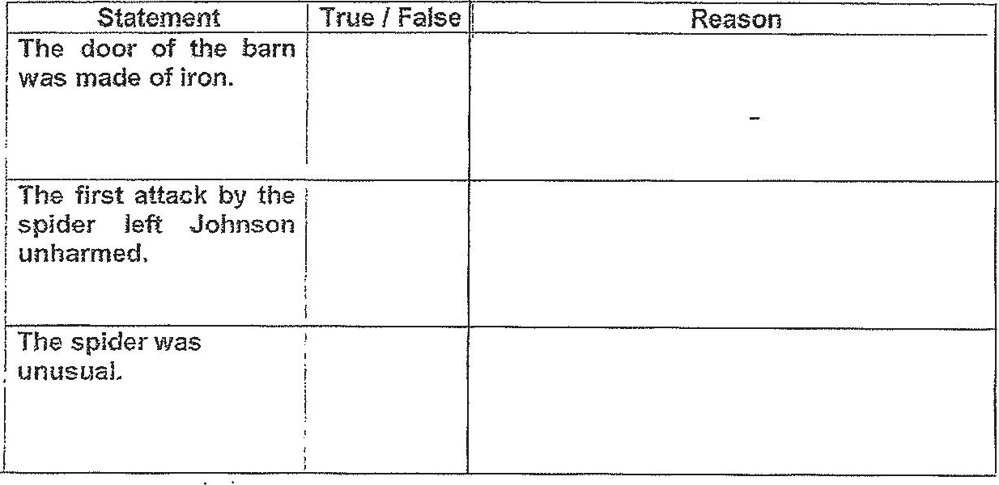

fo dornsoan did not run from ine spider, Cnoose two traits of the spicer that made Johnson  
stay stil id nol run from it. Put a tick (x) in the box beside each of your answers. [21]  
BO NOT TICK MORE THAN TVWVO BOXES.

a tT EE I re  
. | huge | t athletic  
Ij: _. ______________________ oo _________ _________  
  
Palort . | SMAATT !  
  
2 i ! :  
[owe _________ _________ a  
  
' careless : | cautious |  
  
i ___________________________________ ee

al. “hen Jonason said, Let me have another go at fi. (line 42). what do you think he  
intended to do? Why da vou think he said that? f2rn)

END OF PAPER